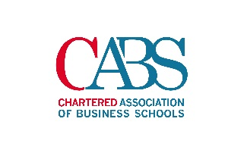
Chartered ABS Scholarship application (Research)

Your application should include the following:
- Name(s) of applicants(s)
- Applicant contact details
- Business school(s) in which you are employed
- Working title
- Research question(s)
- A brief (maximum 300 words) summary on the background of your research and why it is important.
- Methodology
- Intended outputs
- Uses of outputs
- Is this research being submitted for any other funding? If so, where?
- Funding amount being requested
- An attached copy of your cv(s)
- Confirmation that you have read and understood the required deliverables
- Confirmation that you have read an understood the Chartered ABS Privacy Policy

1 | Name(s) of Applicant(s)
2 | Your Contact Details
- email address:
- phone number:

3 | Business school(s) / institution(s) in which you are employed
4 | Working title of research/project
5 | Research question(s)
6 | Brief background of the research and why it is important (up to 300 words)
7 | Methodology
8 | Intended Outputs
9 | Uses of outputs
10 | Please specify whether you have applied for any other sources of funding for this piece of research, and if so where.
 | I have not applied for any alternative sources of funding: ☐
11 | Please specify the amount of funding you are requesting from Chartered ABS
12 | Please confirm that you have attached a copy of your CV with your application
CV is attached: ☐

Please note that you are responsible for ensuring we receive all necessary supporting materials.
13 | Please confirm that you have read and understood the required deliverables
 | I have read and understood the required deliverables: ☐
14 | Please confirm that you have read and understood the Chartered ABS Privacy Policy
In completing this submission your details, including any personal data provided, will be added to our database and processed in accordance with our Privacy Policy. Our Privacy Policy can be found here: https://charteredabs.org/privacy-policy/

I have read and understood the Chartered ABS Privacy Policy: ☐

Please send your completed application and supporting materials to Chartered ABS Research Manager Ramin Bokaian at ramin.bokaian@charteredabs.org by 20 July 2018. It is the current intention that a decision will be made by 31 July. Awards will be for a one-year duration.

